Assignment 1

1. 45.33.32.156 Machine
2. Find all open ports:-

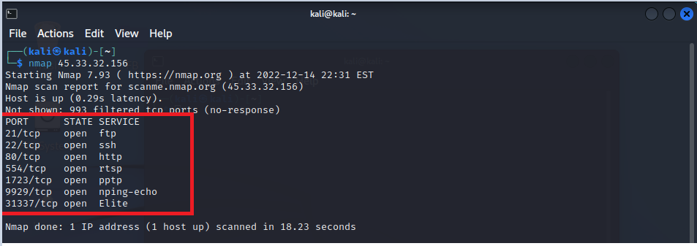

So these are all open ports.

1. Find services running on those port :-

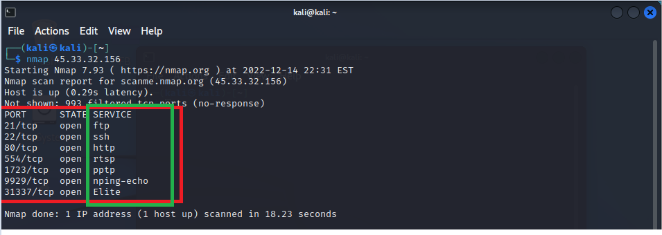

So these are services on these open ports are running.

1. Find version of each service:-

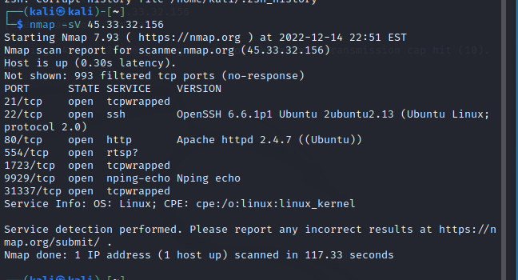

1. Which Operating System is running on this machine

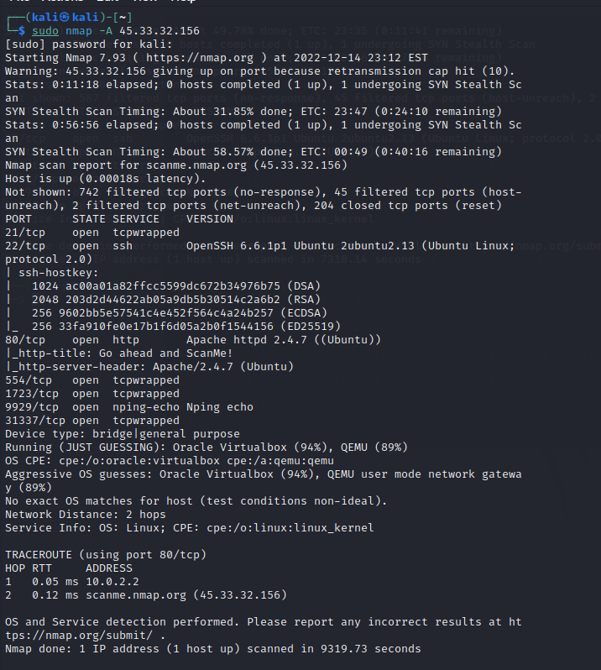

So , OS : Linux

1. check any firewall is configured on this machine:- 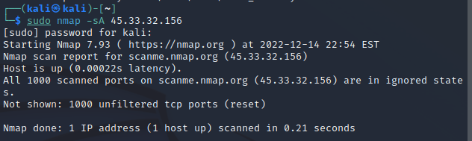

As there 1000 unfiltered tcp ports , so any firewall is not present on this machine.

2.)Check the security of this website. <http://demo.testfire.net/login.jsp>

( List out the vulnerabilities :- SQL injection vulnerable , XSS vulnerable.)

Username :- ‘ or 1=1--

Password:- ‘ or 1=1-- { By using SQL injection }

By using the above username and password I login in the above website.

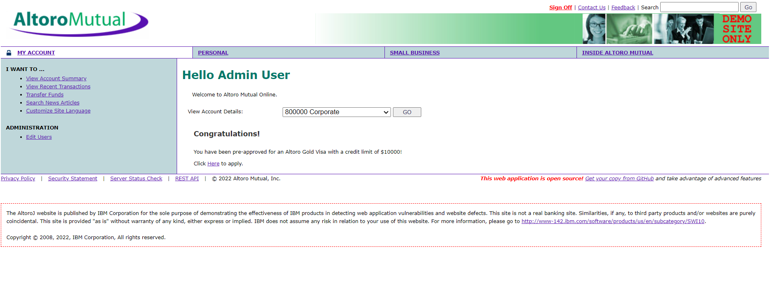

b.) Is this site Xss vulnerable ?

Ans:- YES.

if I apply some java script in search option , like below (<script> aleart(“HELLO”) </script> ) , then it will executed .

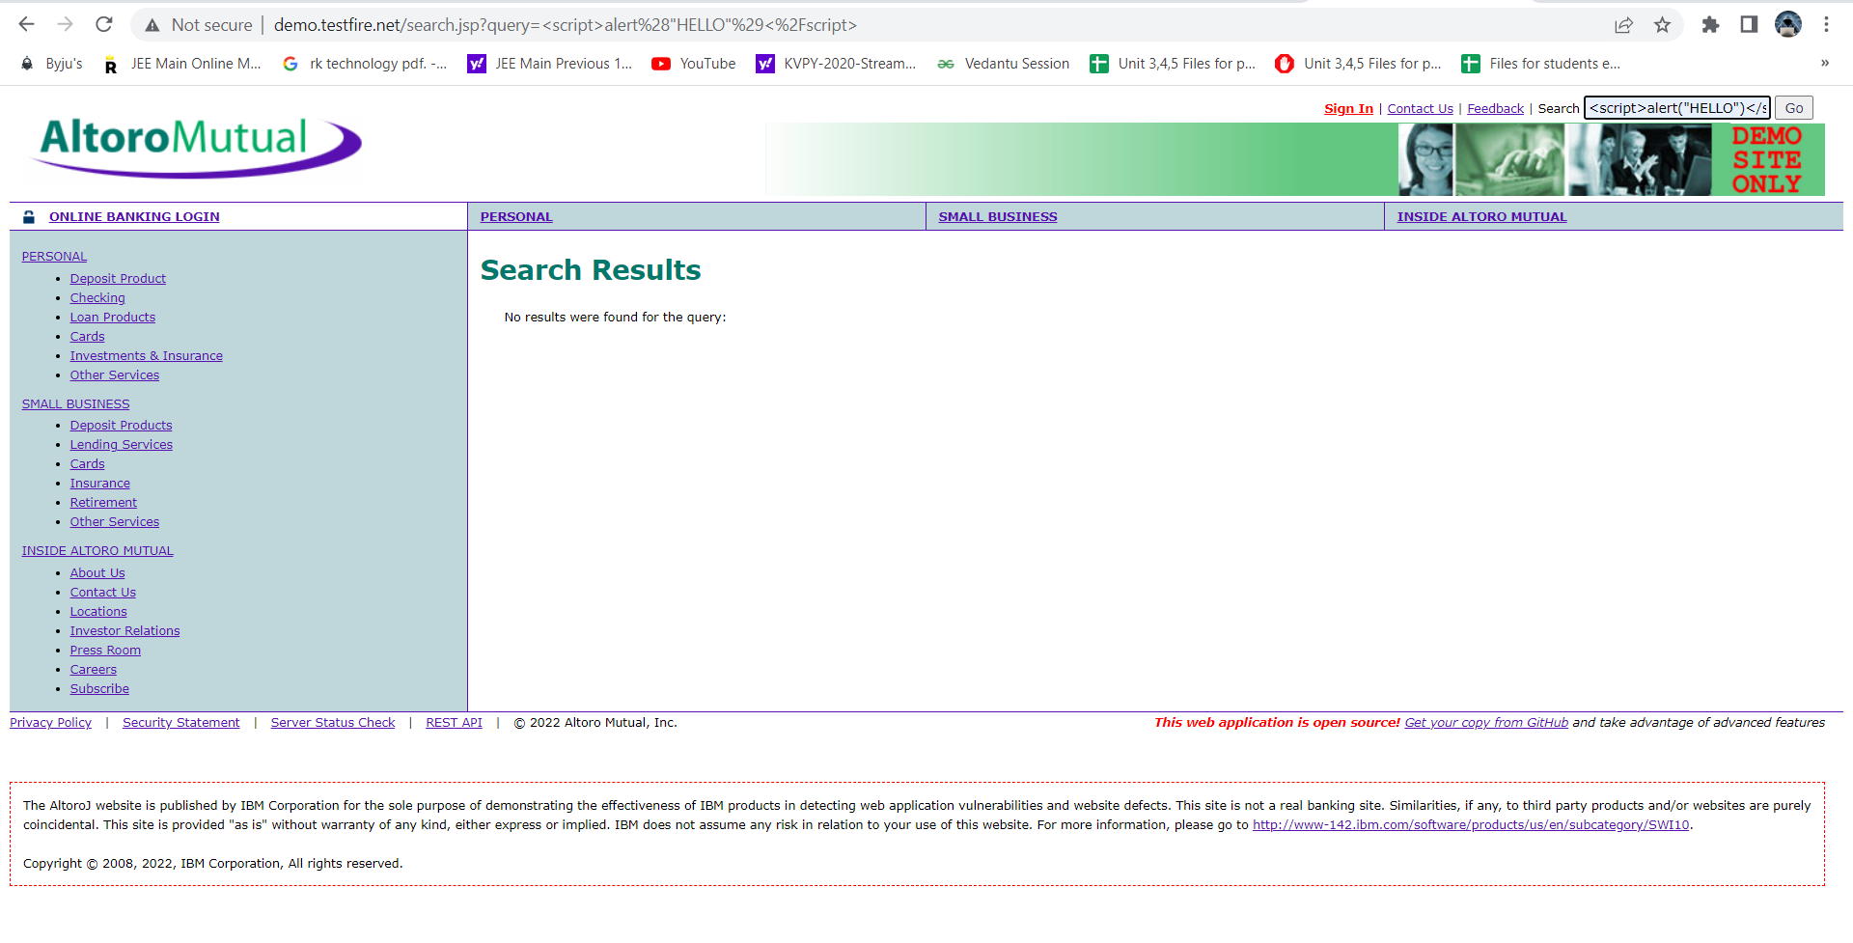

And showing that execution as :-

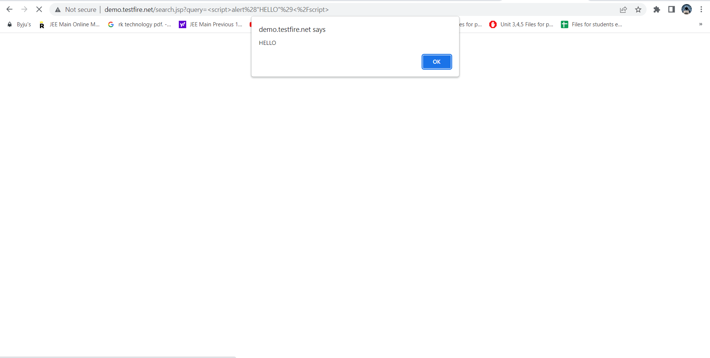

So the website is XSS vulnerable